CSC 110 2.0 Object Oriented Programming
Tutorial 10
----------------------------------------------------------------------------------------------------------------
Instructions:
- All questions must be attempted and answers submitted in a handwritten document, on or before 4.00pm on Monday, 28th October 2019, to the Department Office.
- You must indicate your Index Number and the Tutorial Class to which you belong to (LCS1/ LCS2/ NFC3.1) clearly on the front page of your submission.
- Recommended Time Duration: 1 hour and 10 minutes
----------------------------------------------------------------------------------------------------------------
Examination Practice
01.
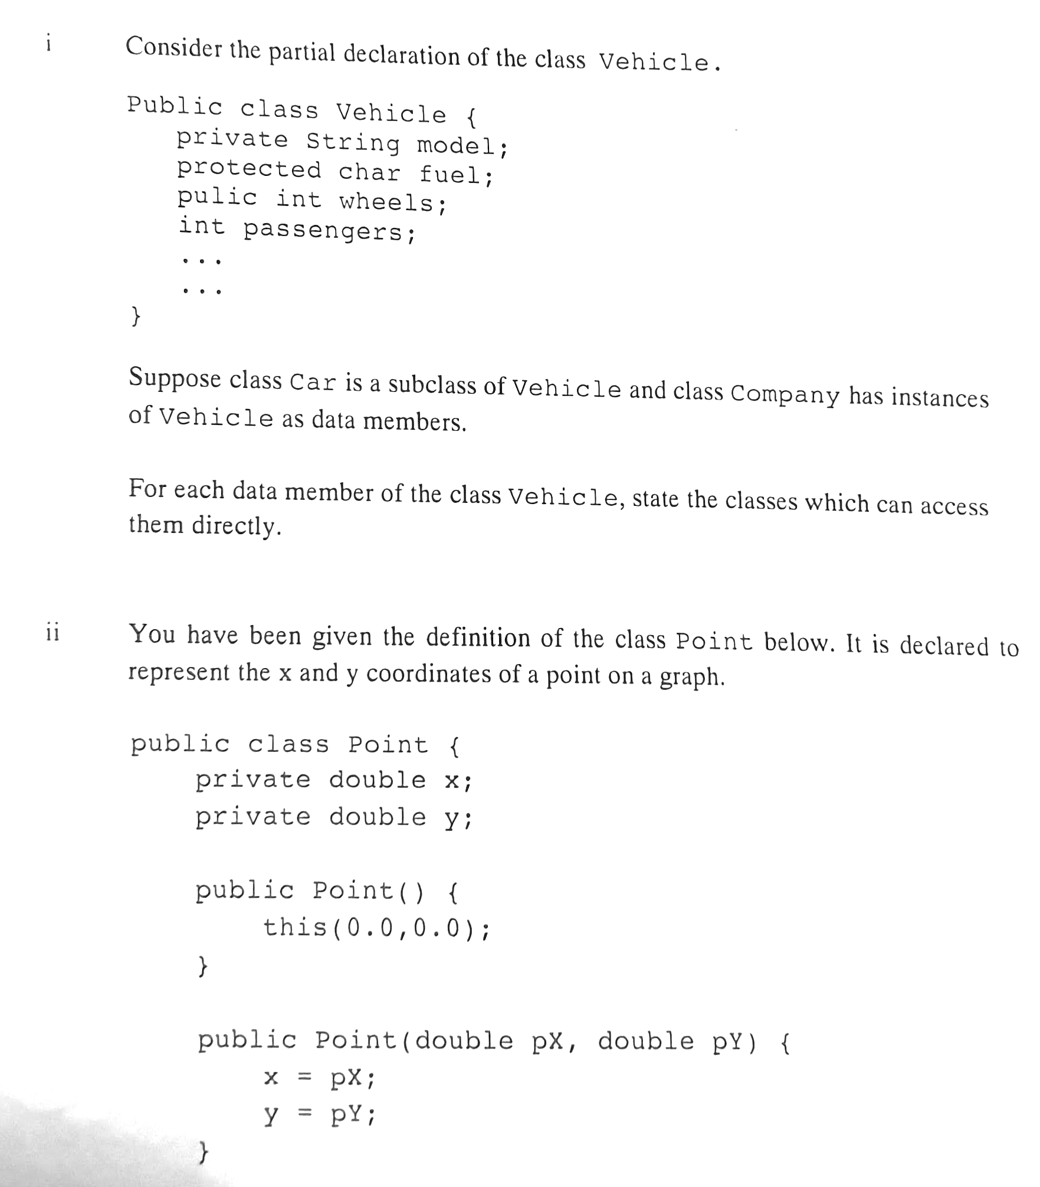

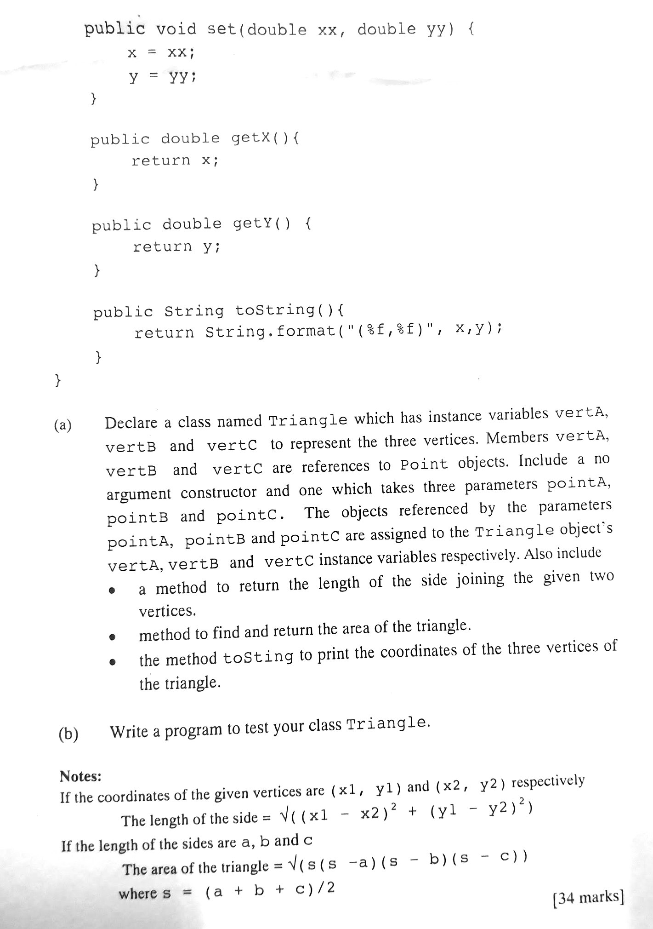

02.
* * * * * * * *

